**1.2**

**Android Architecture**

**Android architecture** is a software stack of components to support a mobile device needs. Android software stack contains a Linux Kernel, collection of c/c++ libraries which is exposed through an application framework services, runtime and application.

Following are main components of android architecture those are

1. Applications
2. Android Framework
3. Android Runtime
4. Platform Libraries
5. Linux Kernel

In these components **Linux Kernel** is the main component in android to provide its operating system functions to mobile and **Dalvik Virutal Machine** (**DVM**) which is responsible for running a mobile application.

Following is the pictorial representation of android architecture with different components.

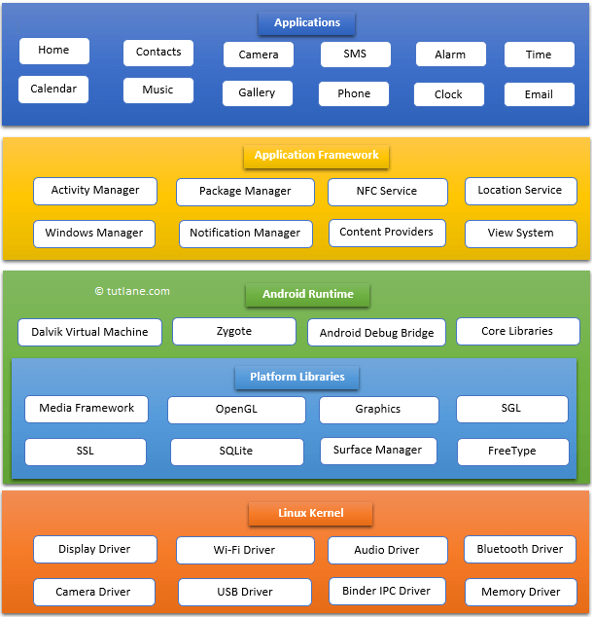

**Applications**

The top layer of android architecture is **Applications**. The native and third party applications like contacts, email, music, gallery, clock, games, etc. whatever we will built those will be installed on this layer only.

The application layer runs within the Android run time using the classes and services made available from the application framework.

**Application Framework**

The **Application Framework** provides the classes used to create an Android applications. It also provides a generic abstraction for hardware access and manages the user interface and application resources. It basically provides the services through which we can create the particular class and make that class helpful for the Applications creation.

The application framework includes services like telephony service, location services, notification manager, NFC service, view system, etc. which we can use for application development as per our requirements.

**Android Runtime**

**Android Runtime** environment is an important part of Android rather than an internal part and it contains a components like **core libraries** and the **Dalvik virtual machine**. The Android run time is the engine that powers our applications along with the libraries and it forms the basis for the application framework.

**Dalvik Virtual Machine** (**DVM**) is a register-based virtual machine like Java Virtual Machine (JVM). It is specially designed and optimized for android to ensure that a device can run multiple instances efficiently. It relies on the Linux kernel for threading and low-level memory management.

The **core libraries** in android runtime will enable us to implement an android applications using standard JAVA programming language.

**Platform Libraries**

The **Platform Libraries** includes various C/C++ core libraries and Java based libraries such as SSL, libc, Graphics, SQLite, Webkit, Media, Surface Manger, OpenGL etc. to provide a support for android development.

Following are the summary details of some core android libraries available for android development.

* Media library for playing and recording an audio and video formats
* The Surface manager library to provide a display management
* SGL and OpenGL Graphics libraries for 2D and 3D graphics
* SQLite is for database support and FreeType for font support
* Web-Kit for web browser support and SSL for Internet security.

**Linux Kernel**

Linux Kernel is a bottom layer and heart of the android architecture. It manage all the drivers such as display drivers, camera drivers, Bluetooth drivers, audio drivers, memory drivers, etc. which are mainly required for the android device during the runtime.

The Linux Kernel will provides an abstraction layer between the device hardware and the remainder of the stack. It is responsible for memory management, power management, device management, resource access, etc.

**Questions**

# Draw the Android Architecture (Software Stack of Android) and explain the roles and features of each layers.

OR

1. How many layers are in Android Architecture? Explain the roles and features of each layers.
2. What are the roles and features of Linux Kernel, Hardware Abstraction Layer (HAL) and Applications?
3. What are the roles and features of Android Runtime (ART)?
4. What are the roles and features of Android Libraries?
5. What are the roles and features of Android Application Framework?